Ski-Bees Ski Club

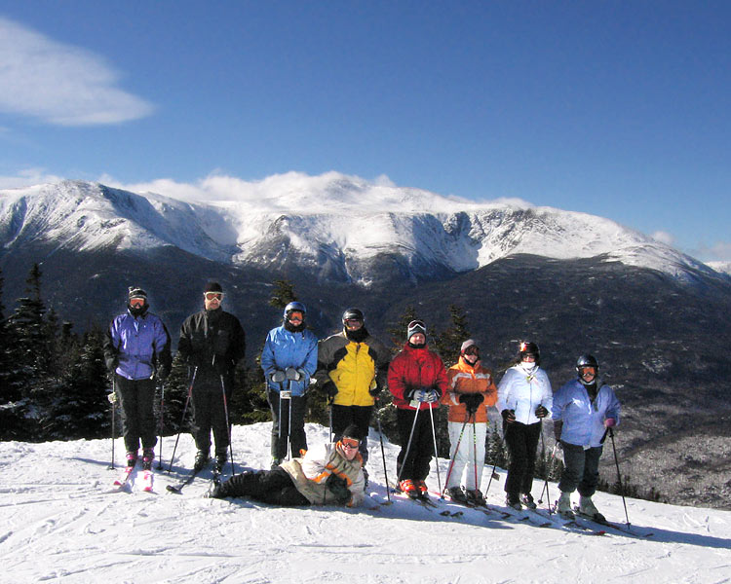

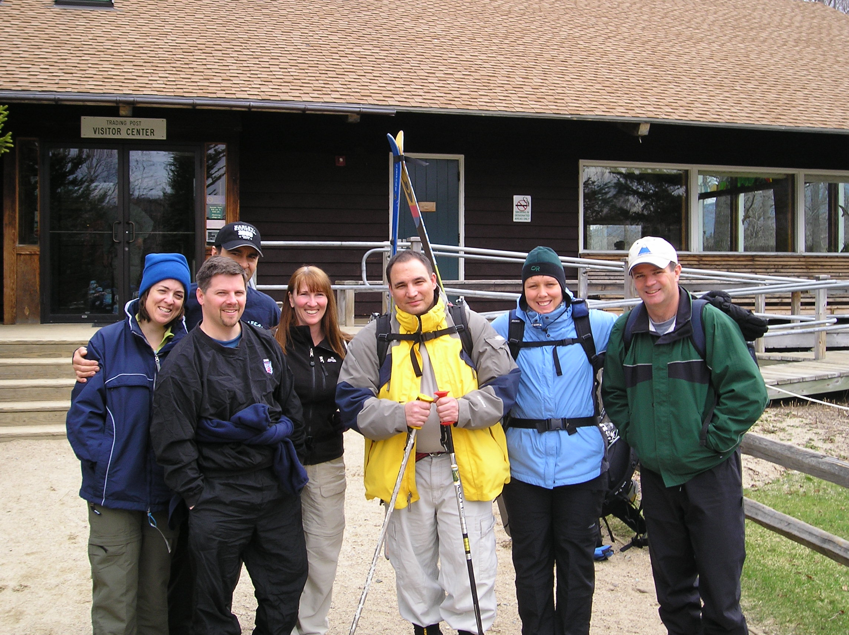

Membership Requirements
- Prospective members must be at least 21 years old & attend three organized events. Two of these events should be organized weekends at the club so we can get to know each other.
- An application, complete with photo and $5 must be submitted.
- Full members are required to contribute twelve hours per year during our work weekends. These weekends are spent cleaning and improving the house and are actually a lot of fun.

In addition to the above requirements, prospective members should be people looking to socialize and have a good time. A willingness to sleep in close quarters (our same-sex bedrooms are shared) and pitch in to help out around the house are a must.

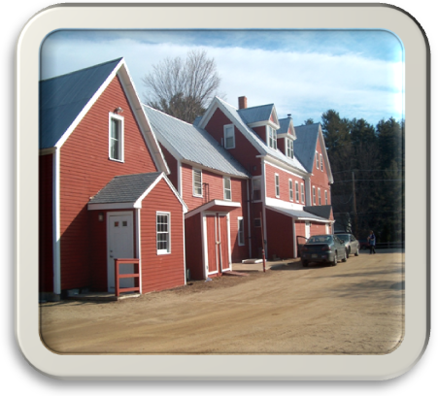

The best way to really understand the club dynamic & experience the fun is to spend a weekend with us! Don’t hesitate to contact us about being our guest for the weekend. Many of our members joined without knowing anyone, so don’t be shy!

Ski-Bees Ski Club
There’s something for everyone……

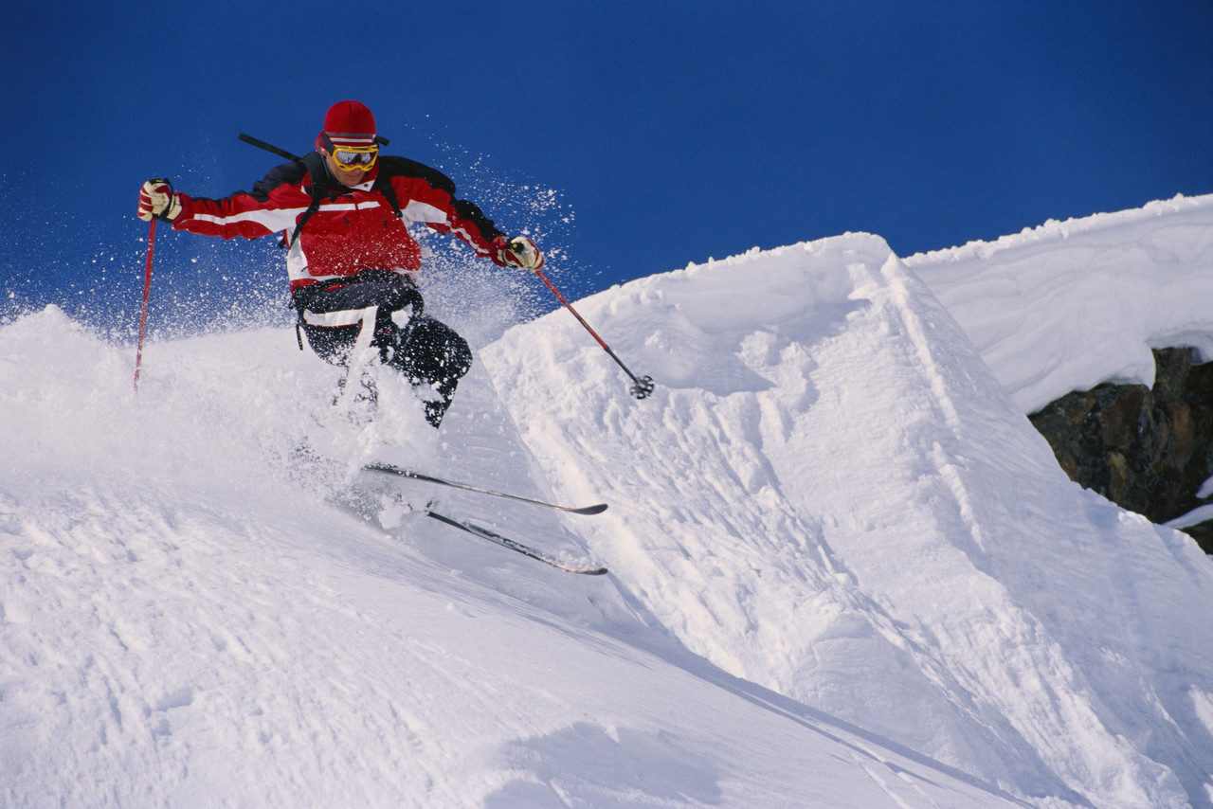

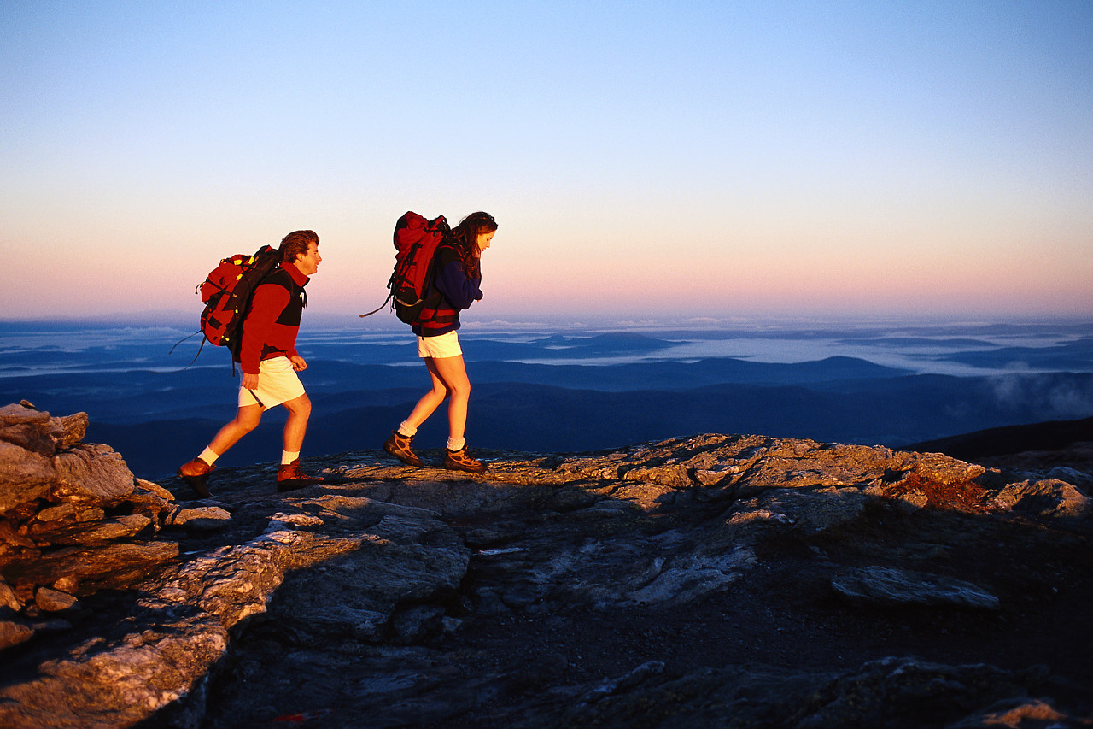

Ski-Bees Ski Club
Kearsarge Road
North Conway, New Hampshire
www.ski-bees.com

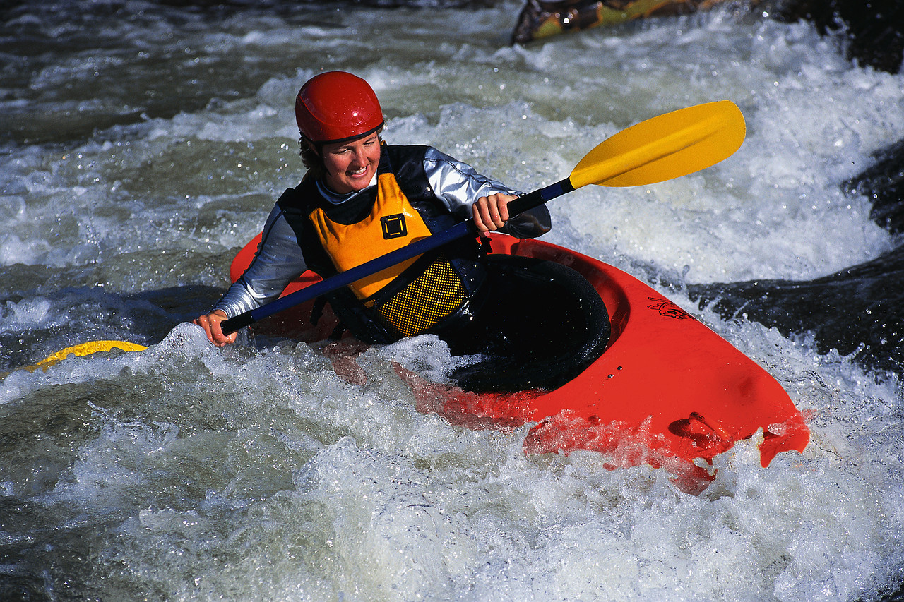

What we do…………..
The Ski-Bees Ski Club is a member of the Eastern Inter-Club Ski League (EICSL) which consists of 21 ski and sport clubs in the Mount Washington Valley. While most of our members ski or snowboard, there are many other nearby activities we enjoy:

- Hike, kayak and canoe
- Mountain bike
- Cross-country ski
- Snow shoe
- Ski and snowboard racing
- Snow tubing
- Swimming and river tubing
- Golf and tennis
- Socializing with other clubs
- Shop & explore North Conway

We are active year-round and no one should feel left out if they do not ski or snowboard. Beginners are welcome as well as seasoned racers. There is truly something for everyone.

Socializing
Après-ski events, cookouts and dinners are a BIG part of our club activities. Many members and guests have said they have never met a bigger, more diverse group of people anywhere.

One of the best things about the Ski-Bees is the location. Sitting in the heart of Mt Washington Valley, just moments away from downtown North Conway, here are just a few of the great attractions located in the area.

- Cranmore Ski Resort (5 minutes away!)
- Attitash Bear Peak Ski Area
- Wildcat Mountain Ski Area
- Black Mountain
- Bretton Woods
- Jackson X-Country Ski Foundation
- Sunday River (it’s a little further than other mountains but many members make the trek out there)
- Saco River (for kayaking, tubing or canoeing)
- Lots of restaurants and bars
- Outlet malls
- Echo Lake
- Hiking trails too numerous to mention

If you would like more information, or want to spend a weekend as a guest at our house, please contact us at
www.ski-bees.com/contact_info_new.htm

We are also on Facebook and Instagram:
www.facebook.com/ski.bees.3
www.instagram.com/iloveskibees/
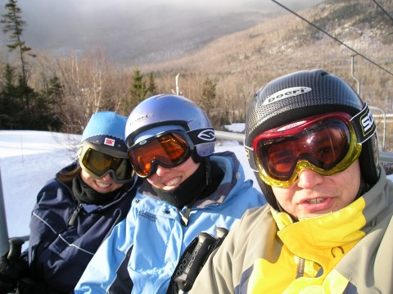

Where we stay………….
The club’s lodge sleeps up to 73 people in bunk-style rooms and is complete with a full commercial kitchen (complete with cook on organized weekends!). Our dining room seats 100 and doubles as our event room when we host EICSL happenings. In addition, we have a media room with cable TV; two additional lounge areas and a secure ski storage room.

How much does it cost?
Ski-Bees members pay a membership fee ($500 annually) plus a nominal nightly fee each night they stay at the lodge. If you add up the cost of just one weekend at a motel, full price ski passes plus meals, you will find a club membership will be well worth the price. Not to mention the delicious, convenient & inexpensive meals you can purchase in-house, as well as the discounts you get just for being a member.

Did someone say discounts?
All EICSL members have the opportunity to purchase discount lift passes for local mountains, as well as getting discounts at many local restaurants and businesses. Does this sound like a great deal yet?

